**Wenzhou-Kean University Group Assignment-2 Fall 2021**

**CPS 2390 W__ Computer Organization & Architecture   
Name: _Wang Xinyu / W04__________________ ID Number: ____ 1098648___________________**

**Name: _Hu Huize / W04__________________ ID Number: _____1130059___________________**

**Name: _Wang Qixiang / W03______________ ID Number: _____1163951___________________**

# Problem 1 (0.5 Mark)

1. Draw the logic circuit corresponding to the following logic expression. Use only 2- input AND gates, 2- input OR gates, 2-input XOR gate and 1- input NOT gate.
2. Determine output Y when inputs A=’1’, B=’0’ and C=’1’. Y= (((NOT(NOT(A) AND B)) OR NOT(C))XOR A) AND (A OR NOT (C))

**Solution**

Here we use analytical representation of AND, OR, NOT, and XOR gate to simplify the expression: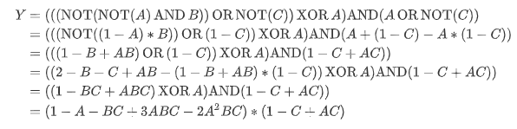

**(a)** Draw the logic circuit corresponding to the following logic expression. Use only 2- input AND gates, 2- input OR gates, 2-input XOR gate and 1- input NOT gate

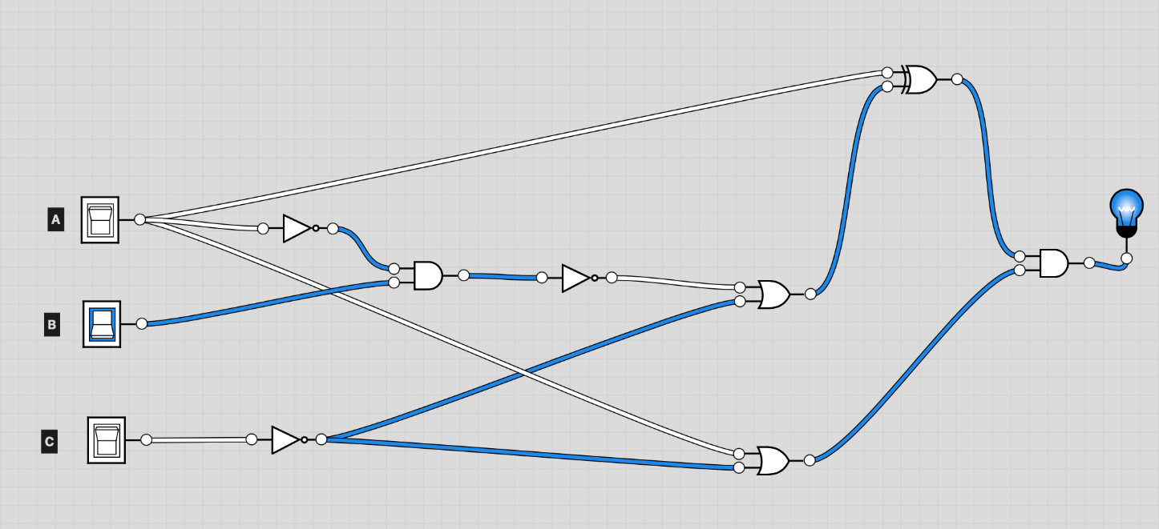

**(b)** Determine output Y when inputs A=’1’, B=’0’ and C=’1’

By the equation, when $A = 1, B = 0, C = 1$, the value of Y is:

$$Y\left(A,B,C\right)=\left(1-1-0+0-0\right)×\left(1-1+1\right)=0$$

# Problem 2 (1 Mark)

1. Implement NOT function using XOR logic gate.
2. Similarly, implement NOT function using XNOR logic gate.

**Solution**

**(a)** Implement NOT function using XOR logic gate.

For the input A, NOT(A) = A XOR(True)

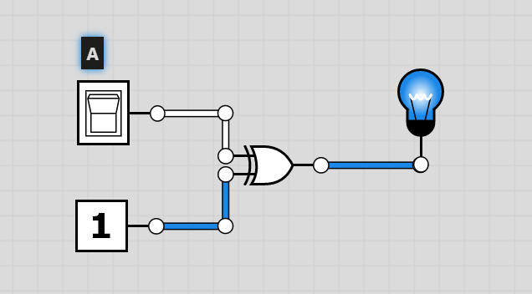

**(b)** Similarly, implement NOT function using XNOR logic gate

For the input A, NOT(A) = A XNOR(False)

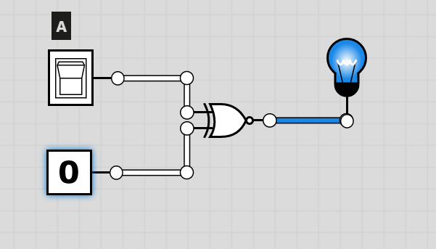

# Problem 3 (1 Mark)

1. Write the Truth –table for the following logic expression.

Y= (NOT((A AND B) OR(B AND C) OR (C AND A))) XOR (NOT(A))

|  |  |  |  |
| --- | --- | --- | --- |
| A | B | C | OUT |
| 0 | 0 | 0 | 0 |
| 0 | 0 | 1 | 0 |
| 0 | 1 | 0 | 0 |
| 0 | 1 | 1 | 1 |
| 1 | 0 | 0 | 1 |
| 1 | 0 | 1 | 0 |
| 1 | 1 | 0 | 0 |
| 1 | 1 | 1 | 0 |

1. Based on the truth table, draw the two-level logic diagram. You can use three-input gates.

# Problem 4 (1 Mark)

* 1. Complete a truth table for the transistor-level circuit given below.

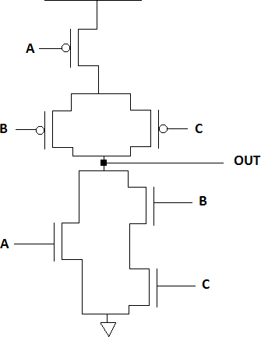

|  |  |  |  |
| --- | --- | --- | --- |
| A | B | C | OUT |
| 0 | 0 | 0 | 1 |
| 0 | 0 | 1 | 1 |
| 0 | 1 | 0 | 1 |
| 0 | 1 | 1 | 0 |
| 1 | 0 | 0 | 0 |
| 1 | 0 | 1 | 0 |
| 1 | 1 | 0 | 0 |
| 1 | 1 | 1 | 0 |

* 1. Complete a truth table for the transistor-level circuit given below. Replace the circuit with a logic gate.

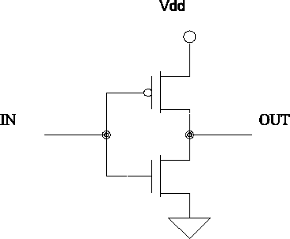

|  |  |
| --- | --- |
| IN | OUT |
| 0 | 1 |
| 1 | 0 |

# 

# Problem 5 (1 Mark)

1. Use 2:1 Multiplexers to implement an 8:1 multiplexer. (Hint: We use three 2:1 multiplexers to implement a 4:1 multiplexer)
2. In your diagram, label inputs i0 – i7, and use select line 510 to determine output Y.

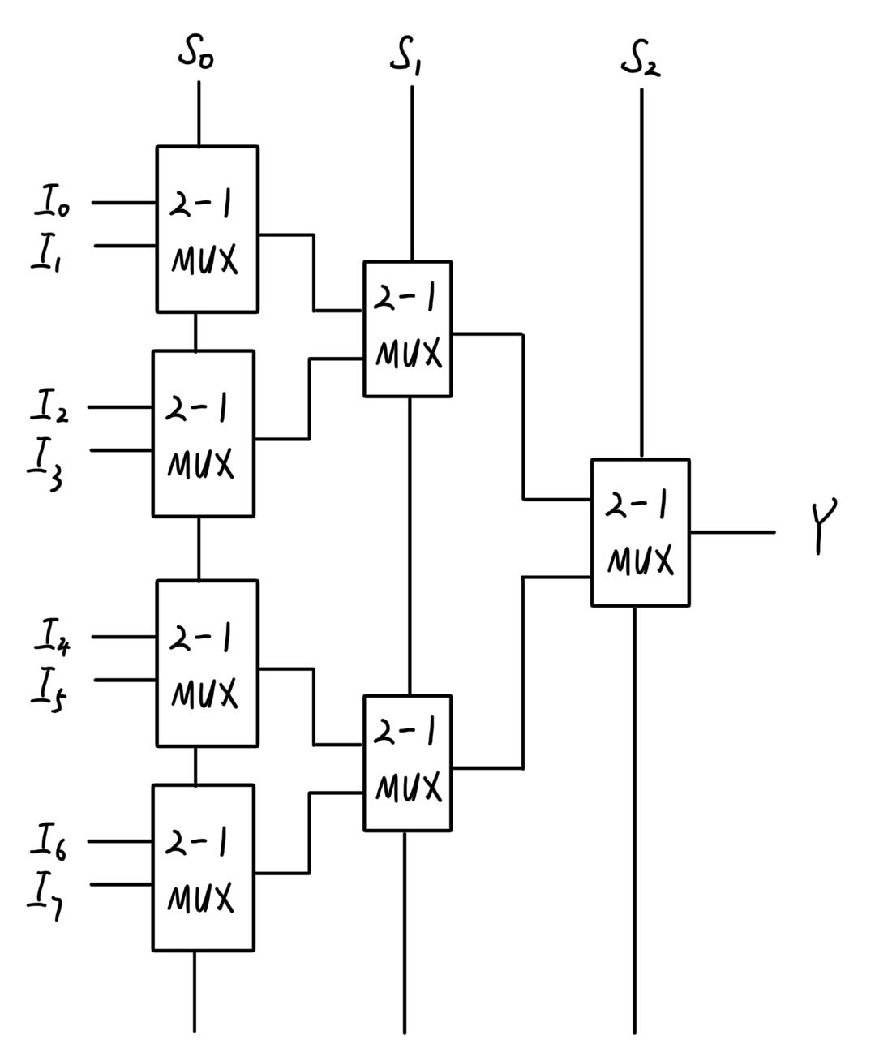

|  |  |  |  |
| --- | --- | --- | --- |
| S0 | S1 | S2 | Y |
| 0 | 0 | 0 | i0 |
| 1 | 0 | 0 | i1 |
| 0 | 1 | 0 | i2 |
| 1 | 1 | 0 | i3 |
| 0 | 0 | 1 | i4 |
| 1 | 0 | 1 | i5 |
| 0 | 1 | 1 | i6 |
| 1 | 1 | 1 | i7 |

# Problem 6 (0.5 Mark)

Complete the table below. A, B and Cin are the inputs to a full adder. S is the sum bit, and Cout is the carry-out bit.

|  |  |  |  |  |
| --- | --- | --- | --- | --- |
| A | B | Cin | S | Cout |
| 0 | 0 | 0 | 0 | 0 |
| 0 | 0 | 1 | 1 | 0 |
| 1 | 1 | 0 | 0 | 1 |
| 1 | 1 | 1 | 1 | 1 |